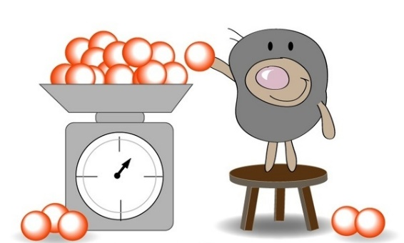
Chem 12 Lab 4D: Molar Mass of an Acid
(From Lab 13G, Part III, Essential Experiments)
This is a formal lab report
Question: What is the molar mass of an unknown
monoprotic acid?
Constraints: The unknown acid is in solid form.
Use approx. 0.60 g of it in your experiment
(but be sure to exactly weigh the amount you use).
You will have access to a standardized base.
Background: Whether an acid is weak or strong, a neutralization reaction can force it to
release all of its H⁺.
Procedure: Design an experimental procedure to answer your question.
Think about which data you will need to answer your question, and about how
much data you need to collect, to be sure you trust your results. What will you
do to collect this data?
Get your teacher to approve the procedure before you begin.

Data: Decide on the best format in which to represent your data.
Be sure to record the letter (A, B, C) of your unknown, and the
concentration of the standardized base.

Conclusion: Make a claim: what is the molar mass of the acid?
Compare your experimental molar mass to the value provided by your teacher.
Was your number too high? Too low? Suggest sources of this error.
If you were to refine your procedure, what would you change?

