Chem 12 Lab 4D: Molar Mass of an Acid - TEACHER NOTES
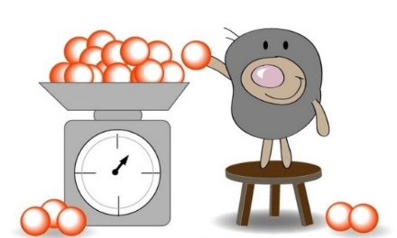
(From Lab 13G, Part III, Essential Experiments)
Constraints: The unknown acids are in solid form.
(we used KHC₈H₄O₄ and KHSO₄)
Use approx. 0.60 g of it in your experiment
(but be sure to exactly weigh the amount you use).
You will have access to a standardized base.

Implementation Details
*The original lab calls for 0.75g of acid.
I chose to use 0.60g of acid with a 0.117M NaOH sample, so that students would not require
more than 50mL of NaOH per trial. (38mL for one acid, less for the other).
*When students tried to come up with a procedure, their first instinct was to look for the pH of the weak acid and complete an ICE table. But without the identity of the acid, they didn’t have a Ka to work with.
*Once students figured out they could titrate to find the moles of acid, they tried to write Bronsted-Lowry acid/base reactions, rather than straightforward neutralizations. They did, eventually, get there… it took some prompting.
*Students had time, in an 80min period, to design a procedure and complete 3 trials.
*Analysis notes: if students did not use the same MASS of solid in each trial, they will not be able to average titration volumes. EITHER – direct students to use identical masses in all 3 trials, OR – have them do the stoichiometry math for all 3 trials, then average the molar masses instead.
*Sources of error:
We used phenolphthalein as an indicator. It worked well for the KHSO₄ (Kb is very small), but it was not as useful for the KHC₈H₄O₄ (Kb ~ 10⁻⁹)… students who observed a faint pink colour with the latter had not yet reached the equivalence point. Their molar masses were too low.
While this prompted an interesting side-conversation about hydrolysis, I wasn’t really prepared to talk about titration curves for weak acids and bases yet. I might try thymolphthalein next time, and avoid this glitch.

