Limiting/Excess Demo
-Watch your teacher’s demonstration.
-You will hand in a conclusion for this demo.

The set-up: 3.0 grams of baking soda, NaHCO₃, is added to different amounts of vinegar.
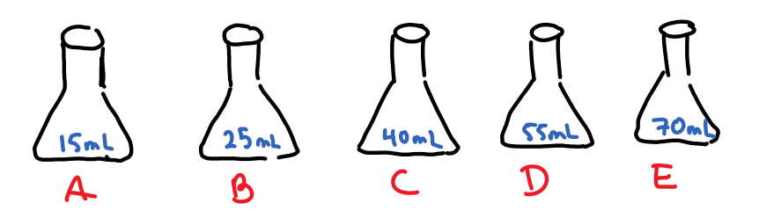

The question:
What was the limiting reactant in each container?
- Answer in Claim/Evidence/Reasoning format.
Reasoning: Use observations about the balloons AND the solutions.
Why do your observations mean what you think they do?

Theory follow-up:
How much acid does the 3.0g of baking soda need to fully react?
Note: [CH₃COOH] = 0.833M
Does this calculated value agree with your observations? Explain.

