Limiting/Excess Demo: Teacher notes
Before the demo:
Pre-stretch 5 balloons. They should be the same size, and same colour (if possible) for visual effect. If you’re inflating them, give them time to dry.
Then, place 3.0g of baking soda, NaHCO₃, into each of 5 balloons.

Measure out the appropriate amount of vinegar into each of the 5 erlenmeyer flasks.

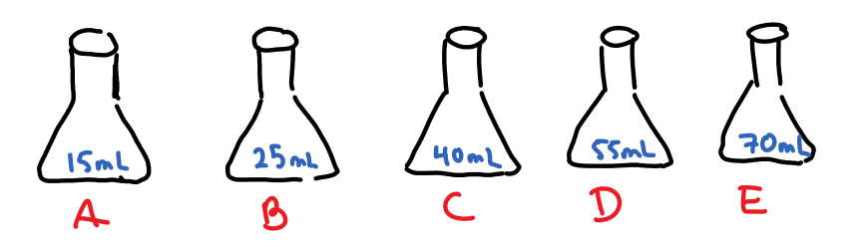

When you are ready to demonstrate, fix the balloon over the neck of the flask. Invert the balloon. Your data will look like this:

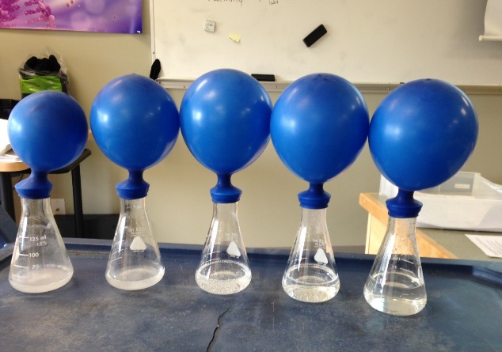
The first two balloons are smaller, and the last 3 are about the same size. (Doesn’t quite look that way in the picture, but my students were convinced!)
There is also residual baking soda in the first two flasks.

The question:
What was the limiting reactant in each container?
- Answer in Claim/Evidence/Reasoning format.
Reasoning: Use observations about the balloons AND the solutions.
Why do your observations mean what you think they do?

Theory follow-up:
How much acid does the 3.0g of baking soda need to fully react?
Note: [CH₃COOH] = 0.833M
Does this calculated value agree with your observations? Explain.

3.0g x (1mol/84.0g) x (1 mol/1mol) x (1L/0.833mol) = 42.9mL
Yes, this makes sense. The 40mL balloon is a fraction smaller than the 50 and 60, but almost the same.

